1. **Python Installation:**

Go to <http://jupyter.org/install.html>.

While Jupyter runs code in many programming languages, Python is a requirement (Python 3.3 or greater, or Python 2.7) for installing the Jupyter Notebook.

Recommend using the Anaconda distribution to install Python and Jupyter.

1. **Installing Jupyter using Anaconda:**

Go to <https://www.continuum.io/downloads>

Download Anaconda. Recommend downloading Anaconda’s latest Python 3 version (currently Python 3.5).

Python 3.6 version

64-BIT INSTALLER (422M)

Install the version of Anaconda which you downloaded,

1. **Go to Anaconda Terminal to run the notebook:**

C:\Users\madhuri jupyter notebook

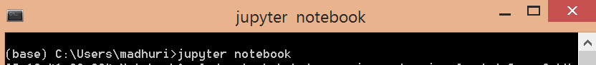

This will print some information about the notebook server in your terminal, including the URL of the web application (by default, http://localhost:8888):

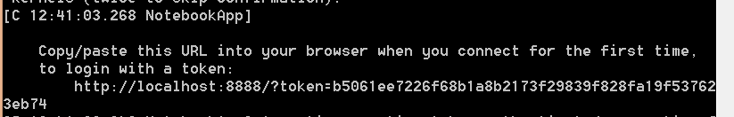

1. **Install scala in Jupyter Notebook**

Ensure you have IPython 3 installed. ipython --version should return a value >= 3.0. If it's not the case, a quick way of setting it up consists in installing the Anaconda Python distribution, and then running

$ pip install --upgrade "ipython[all]"

ipython --version should then return a value >= 3.0.



Download the Jupyter Scala binaries for Scala 2.10 ([txz](https://oss.sonatype.org/content/repositories/snapshots/com/github/alexarchambault/jupyter/jupyter-scala-cli_2.10.5/0.2.0-SNAPSHOT/jupyter-scala_2.10.5-0.2.0-SNAPSHOT.tar.xz) or [zip](https://oss.sonatype.org/content/repositories/snapshots/com/github/alexarchambault/jupyter/jupyter-scala-cli_2.10.5/0.2.0-SNAPSHOT/jupyter-scala_2.10.5-0.2.0-SNAPSHOT.zip)) or Scala 2.11 ([txz](https://oss.sonatype.org/content/repositories/snapshots/com/github/alexarchambault/jupyter/jupyter-scala-cli_2.11.6/0.2.0-SNAPSHOT/jupyter-scala_2.11.6-0.2.0-SNAPSHOT.tar.xz) or [zip](https://oss.sonatype.org/content/repositories/snapshots/com/github/alexarchambault/jupyter/jupyter-scala-cli_2.11.6/0.2.0-SNAPSHOT/jupyter-scala_2.11.6-0.2.0-SNAPSHOT.zip)), and unpack them in a safe place.

For Jupyter-scala script or jupyter-scala.bat file please download the zip file from below url:

<https://oss.sonatype.org/content/repositories/snapshots/com/github/alexarchambault/jupyter/jupyter-scala-cli_2.10.5/0.2.0-SNAPSHOT/jupyter-scala_2.10.5-0.2.0-SNAPSHOT.zip>

Then run once the jupyter-scala program (or jupyter-scala.bat on Windows) it contains.

We can run jupyter-scala.bat file by using call command:

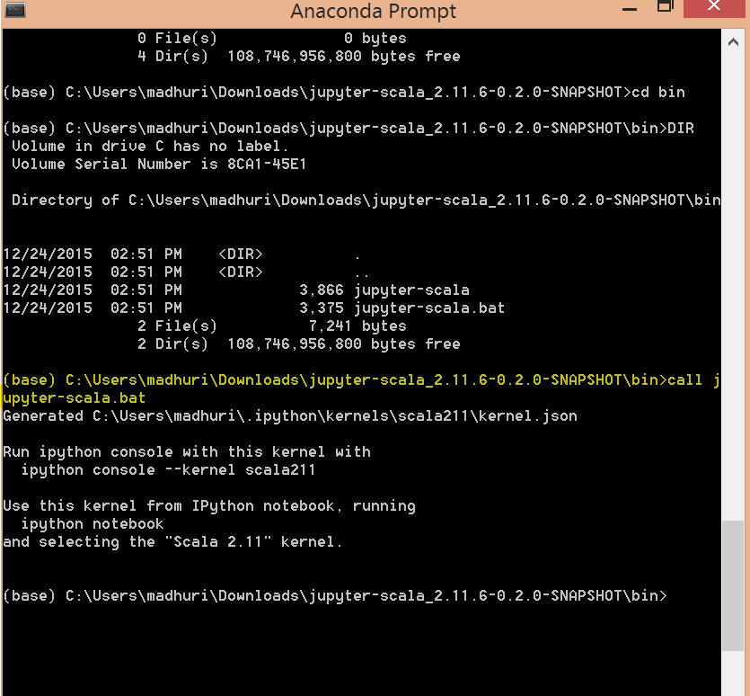

That will set-up the Jupyter Scala kernel for the current user.

Check that Jupyter/IPython knows about Jupyter Scala by running

$ jupyter kernelspec list

This should print, among others, a line like

scala211

(or scala210 dependending on the Scala version you choose).

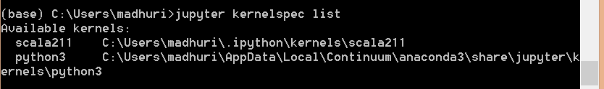

Then run either IPython console with

$ ipython console --kernel scala211

and start using the Jupyter Scala kernel straightaway,

or run Jupyter Notebook with

$ jupyter notebook

Or run ipython notebook

$ ipython notebook

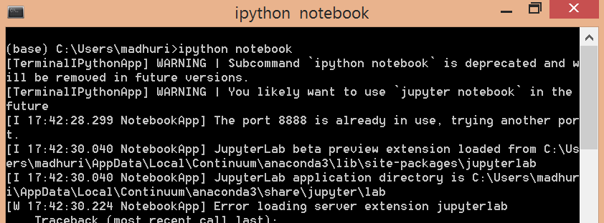

This will print some information about the notebook server in your terminal, including the URL of the web application

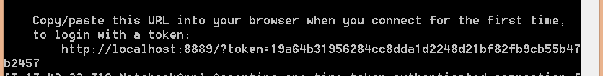

In Browser :

Create Scala 2.11 notebooks by choosing Scala 2.11 in the dropdown in the upper right of the Jupyter Notebook start page.

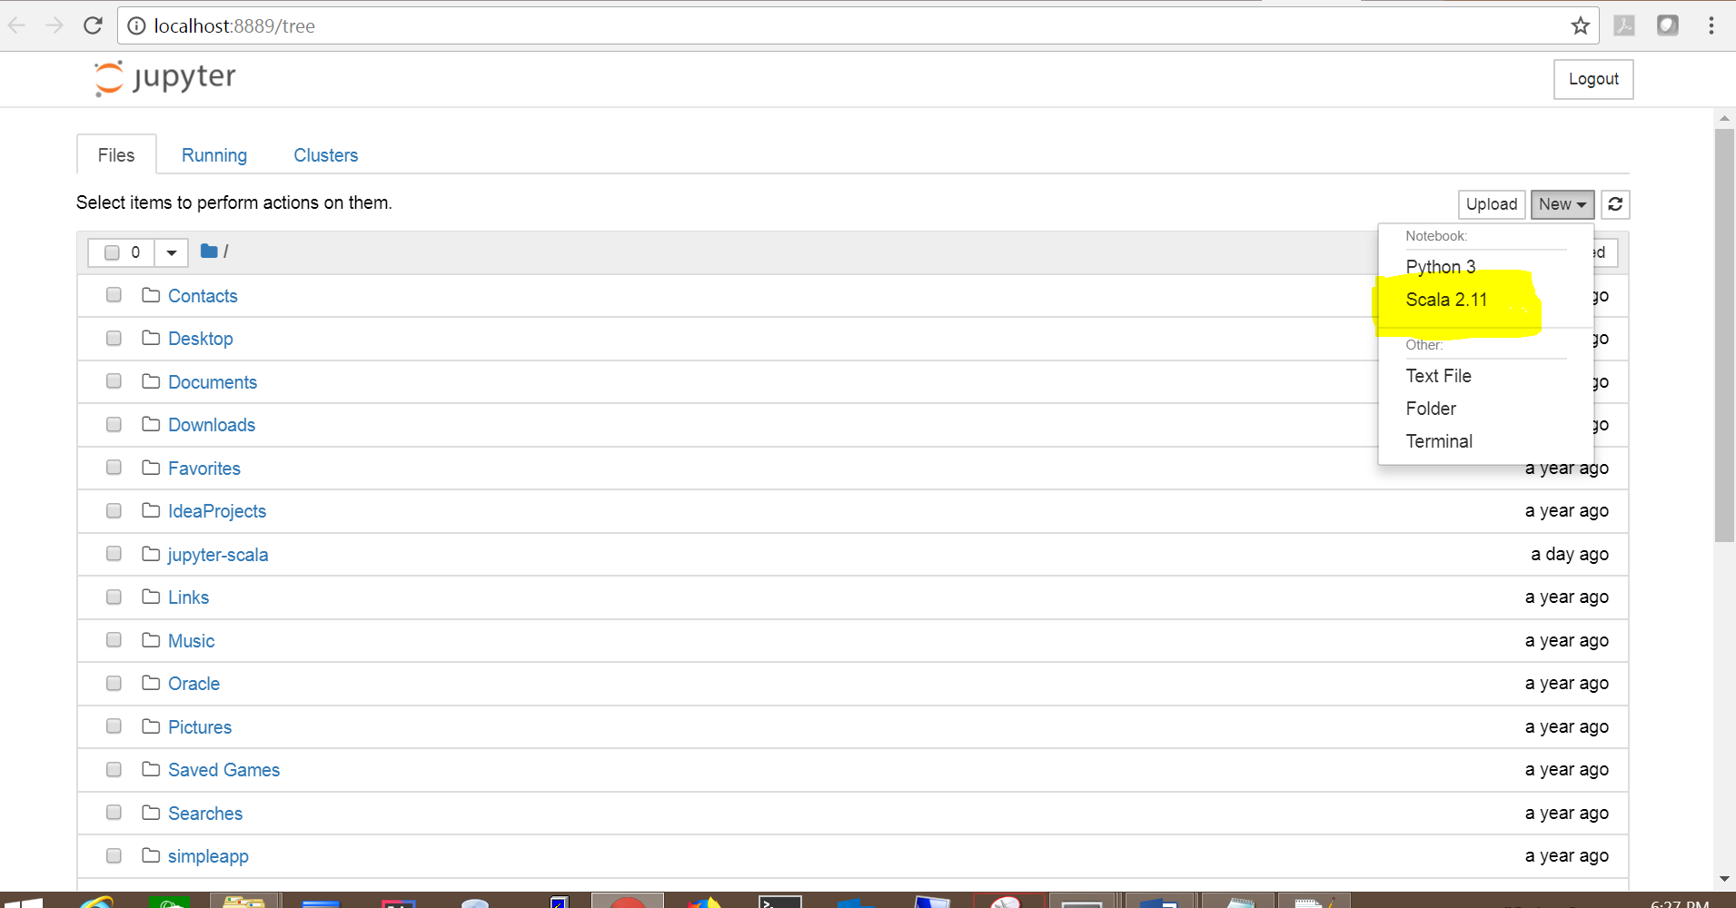

Sample Notebooks:

